Children and Their Safety are Important at Chestnut Hill UMC
We rejoice that as a church we are able to offer carefully planned, age appropriate care and activities for our children and youth.
Today, children ages 6 and above will stay in the sanctuary for worship.
The Nursery for infants up to age 6 is located in Classroom 101 (exit through the right side door at the front of the sanctuary, pass through “the Commons,” go through the double doors to the Education Building and follow the hallway to the
Nursery at the end of the hall on the left).

DIRECTORY OF CHESTNUT HILL UNITED METHODIST CHURCH
 | Sharma Lewis | Richmond Area Resident Bishop
 | Scott Davis | Lynchburg District Superintendent
 | Liz Ecklund | Minister
 | Monica Campbell | Administrative Assistant
 | Heather Wilson | Director of Music Ministry
 | Judy Martin | Bookkeeper
 | Judy Robertson | Lay Leader


Chestnut Hill
United Methodist Church

Making disciples of Jesus Christ
for the transformation of the world.
You are welcome at Chestnut Hill UMC.

4660 Fort Avenue ~ Lynchburg, Virginia 24502
Church: 434-239-8423
Pastor’s Cell: 434-258-2934; Pastor’s Home: 434-319-5646
Email Pastor Liz: Pastorliz@aol.com
chestnuthillumc@comcast.net ~ on the web at chestnuthillumc.net
Find us on Facebook: Chestnut Hill United Methodist Church

Chestnut Hill United Methodist Church
10:30 a.m. ~ June 20, 2021 ~ 4th Sunday after Pentecost
Father’s Day
Our ministry vision for the Virginia Annual Conference is “to be disciples of Jesus Christ who are lifelong learners, who influence others to serve.”
Welcome! Join us in worshiping God!
Welcome and Ministry Announcements
Welcome in the name of Christ our Lord.
Thank you for silencing cell phones as we gather to worship God.
Invocation
Prelude “This is My Father’s World”
Call to Worship
Let us come together and worship, all children of the living God.
In Christ, we are adopted into the family of God.
And the Holy Spirit goes with us, bearing witness of God's love.
Through the storms and through the good times, God is there.
Let us proclaim for all the world to hear God's love in Christ!
Blessed be the name of the Lord!
*Singing Our Faith # 530 “Are Ye Able”
Blessing of the Sanctuary
Prayer of Confession
Words of Assurance
Jesus Christ came to seek and to save the lost and those who are losers in the eyes of this world. We may be assured that to lose our life in Christ is to find it; to confess and give over the burden of our sin to Christ is to find peace and the promise of eternal life. Thanks be to God.

Prayer for Illumination Ann Robbins
Lord, open our hearts and minds by the power of your Holy Spirit, that, as the Scriptures are read and your Word proclaimed, we may hear with joy what you say to us today. Amen
Gospel Lesson Mark 4:35-41 (CEB) Ann Robbins
The Word of God for the people of God.
Thanks be to God.
Singing Our Faith # 122 “God of the Sparrow, God of the Whale”
The Good News “When the Storms of Life Are Raging”
Special Music “Count Your Blessings”
The Prayers of the People
The Lord’s Prayer
Our Father, who art in heaven, hallowed be thy name. Thy kingdom come,
Thy will be done on earth as it is in heaven. Give us this day our daily bread and forgive us our trespasses, as we forgive those who trespass against us. And lead us not into temptation, but deliver us from evil. For thine is the kingdom, and the power, and the glory, forever. Amen.
*Singing Our Faith # 512 “Stand By Me”
*Blessing and Dismissal
*Postlude

Scatter to Serve God & Neighbor
Welcome to all! We gather to praise God for the innumerable blessings given
to us and to grow deeper in the Spirit. Joyfully, let us lift our hearts to God.

**This Week’s Calendar**
Wednesday, 6/23 | 10:00 a.m. | Kitchen Cleaning
Sunday, 6/27 | 11:30 a.m. | Reception for Pastor Liz  We will be serving finger foods and punch. Anyone who can contribute to the food (homemade or purchased) please let Judy Robertson know by email, text or call (drobfor@msn.com, 434-851-2901). Also, we need people to help serve the food and punch.
Chestnut Hill extends Christian love and sympathy to the family of Radford “Sonny” Smith, III and especially to his sister, Barbara LeFew. Mr. Smith passed away on June 2, 2021.

Flowers
The flowers placed in the Commons are in honor of Jeanette Almond’s 96th birthday (June 10) by her daughter, Carolyn Phelps.
In the Grocery Cart This Month:
For JUNE/JULY/AUGUST:
Snack foods : Granola Bars, Breakfast Bars, packs of crackers, snack size bags of chips, fruit cups, and Applesauce cups.
Other Needs: Laundry detergent, dish liquid, multi-surface cleaner, paper towels, toilet paper, baby wipes, diapers sizes 5 & 6, body wash, shampoo & conditioner, and razors.
Place donations in the grocery cart, located in the Commons.
**NOTE: Please put all liquids in the box provided. Tape down all flip top bottles. AND no “baked goods” of any kind.

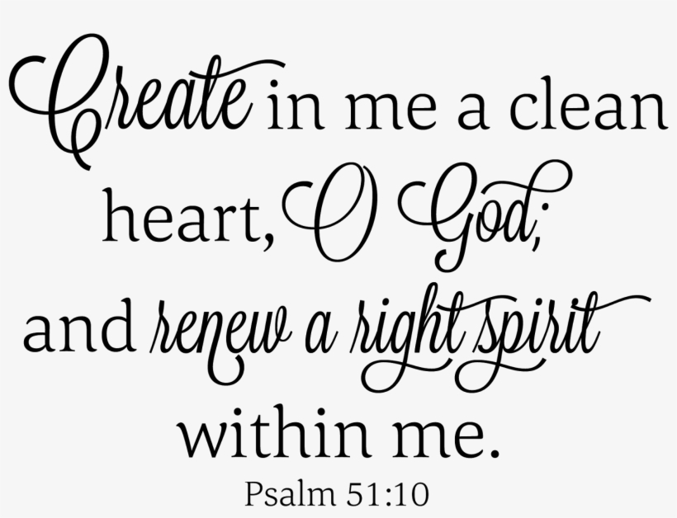

**This Week’s Calendar**
Wednesday, 6/23 | 10:00 a.m. | Kitchen Cleaning
Sunday, 6/27 | 11:30 a.m. | Reception for Pastor Liz  We will be serving finger foods and punch. Anyone who can contribute to the food (homemade or purchased) please let Judy Robertson know by email, text or call (drobfor@msn.com, 434-851-2901). Also, we need people to help serve the food and punch.
Chestnut Hill extends Christian love and sympathy to the family of Radford “Sonny” Smith, III and especially to his sister, Barbara LeFew. Mr. Smith passed away on June 2, 2021.

Flowers
The flowers placed in the Commons are in honor of Jeanette Almond’s 96th birthday (June 10) by her daughter, Carolyn Phelps.
In the Grocery Cart This Month:
For JUNE/JULY/AUGUST:
Snack foods : Granola Bars, Breakfast Bars, packs of crackers, snack size bags of chips, fruit cups, and Applesauce cups.
Other Needs: Laundry detergent, dish liquid, multi-surface cleaner, paper towels, toilet paper, baby wipes, diapers sizes 5 & 6, body wash, shampoo & conditioner, and razors.
Place donations in the grocery cart, located in the Commons.
**NOTE: Please put all liquids in the box provided. Tape down all flip top bottles. AND no “baked goods” of any kind.

